Forecasting Hourly Appliance Energy Consumption
A Comparison of Benchmark, Statistical, Machine Learning, Deep Learning and Foundation-Model Approaches
Module 7PAM2033 — Time Series Analysis |
Student Name Nimra Khizar | Student ID: 24142732

1. Introduction
Home appliance energy consumption is highly variable and driven by occupant behaviour, time-of-day routines, and ambient conditions. Accurate short-horizon forecasts of this consumption support demand-response, smart-home automation and grid-balancing applications. This report develops and compares six forecasting approaches for the UCI Appliances Energy Prediction dataset: four naive benchmark models, an ARMA model, a seasonal SARIMAX model, a feature-based XGBoost regressor, an LSTM neural network, and the Chronos-Bolt time-series foundation model. All models are evaluated on a common 24-hour-ahead forecasting task using RMSE, MAE and MAPE.

2. Data and Exploratory Analysis
The dataset records appliance energy use (Wh) alongside indoor temperature/humidity from nine rooms and outdoor weather variables, sampled every 10 minutes between 11 January and 27 May 2016. For this analysis the data were resampled to hourly means using pandas, producing 3,290 clean hourly observations with no missing values after resampling.
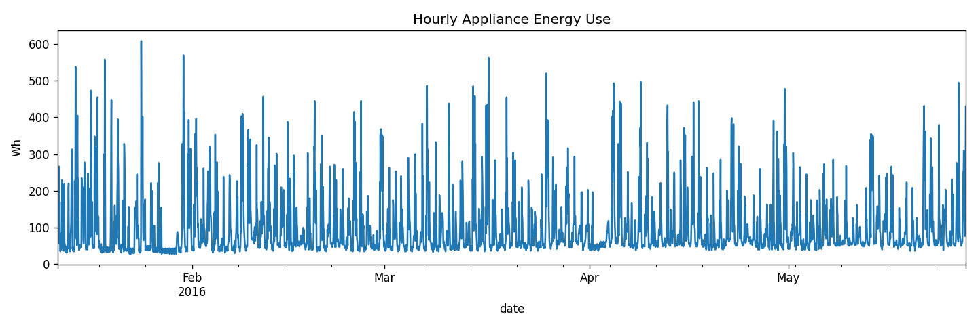
Figure 1: Hourly appliance energy consumption over the full study period.
An additive seasonal decomposition (period = 24 hours) separates the series into trend, daily-seasonal and residual components.
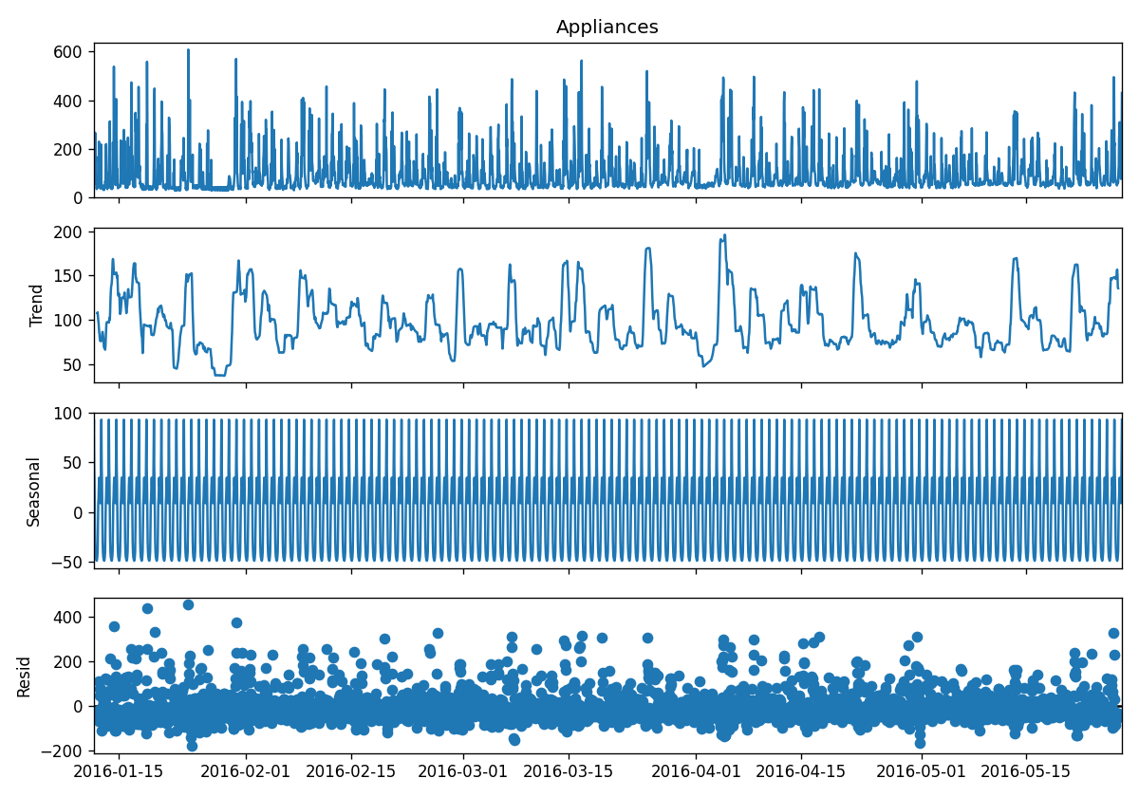
Figure 2: Additive seasonal decomposition (24h period) of hourly Appliances.
The decomposition shows a clearly repeating daily cycle, consistent with morning and evening occupancy-driven usage peaks, superimposed on a slowly varying trend.

2.1 Stationarity Testing
An Augmented Dickey-Fuller (ADF) test and a KPSS test were applied to the hourly series. The ADF test strongly rejected the unit-root null hypothesis (statistic = -8.95, p < 0.001), and the KPSS test failed to reject its stationarity null (p = 0.10), jointly indicating the level series is already stationary in the mean. ACF and PACF plots (48 lags) were also inspected.
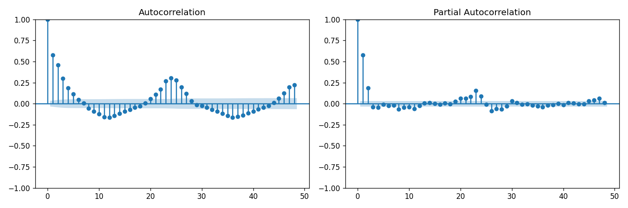
Figure 3: ACF and PACF of the hourly Appliances series (48 lags).
Despite mean-stationarity, the ACF shows a slowly-decaying, strongly periodic pattern with a clear spike at lag 24, evidencing pronounced daily seasonality that a non-seasonal model cannot capture — this directly motivates the seasonal SARIMAX specification in Section 4.2.

3. Forecasting Problem Definition
- Target variable: Appliances — hourly electricity consumption (Wh).
- Forecast horizon: 24 hours ahead.
- Train/test split: the final 24 hours of the hourly series are held out as a common test window for all models (benchmarks, ARMA, SARIMAX, LSTM); XGBoost additionally uses the final 14 days as a held-out evaluation period, with its final 24 hours reported separately for cross-model comparability.
- Evaluation metrics: RMSE, MAE, MAPE.

4. Modelling

4.1 Benchmark Models
Four standard benchmarks were implemented: Mean (historical average), Naive (last observed value repeated), Seasonal Naive (value from the same hour one day earlier), and Drift (linear extrapolation between the first and last training points). These provide a baseline against which more sophisticated models must demonstrate genuine skill; if a complex model cannot beat a seasonal naive forecast, it is not capturing anything the naive structure does not already exploit.
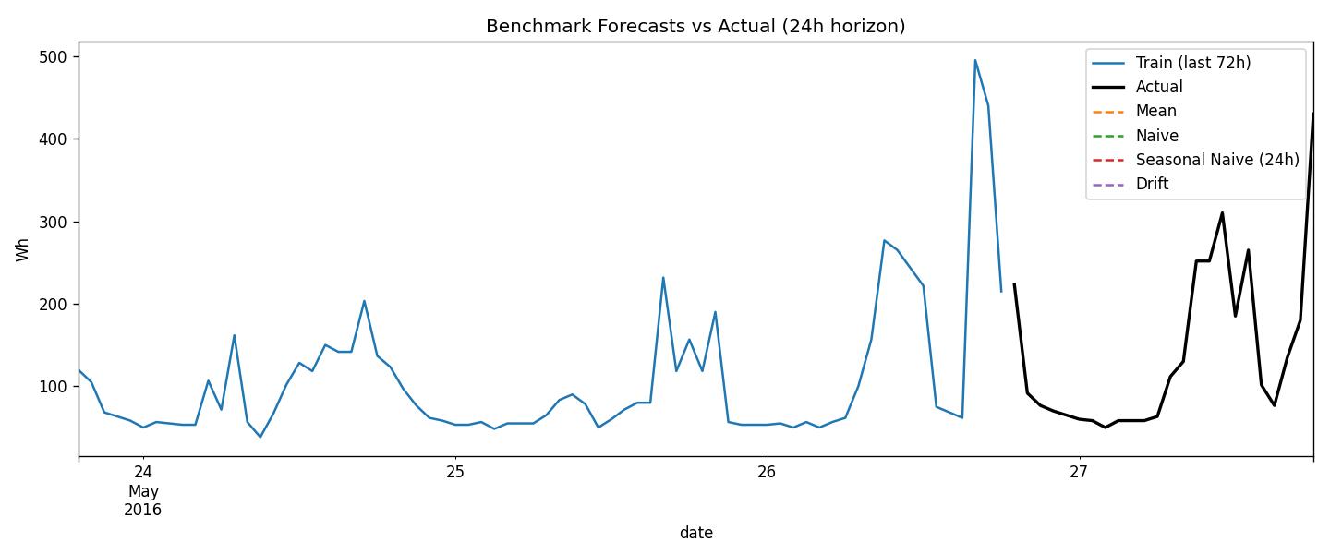
Figure 4: Benchmark forecasts against the actual 24-hour test window.

4.2 ARMA
A non-seasonal ARMA(p,0,q) model was fitted using statsmodels, with the order selected via an AIC grid search over p,q ∈ [0,3]. ARMA was chosen as an autoregressive baseline that captures short-range temporal dependence, but — unlike SARIMAX — it cannot represent the 24-hour periodicity identified in Section 2.1, so it is expected to underperform on a strongly seasonal series.

4.3 SARIMAX
A Seasonal ARIMA model (SARIMAX) was fitted with a fixed daily seasonal order of (1,1,1,24) while the non-seasonal order (p,d,q) was selected via an exhaustive AIC grid search over p ∈ [0,6], d ∈ [0,2], q ∈ [0,6] — 147 combinations in total, as required by the assignment brief. For computational tractability the grid search itself was run on the most recent 30 days of training data, and the selected order was then refit on the full training set for the final forecast. SARIMAX was chosen specifically because it can model the daily seasonality that ARMA cannot, directly addressing the periodic structure found in the ACF/PACF diagnostics.
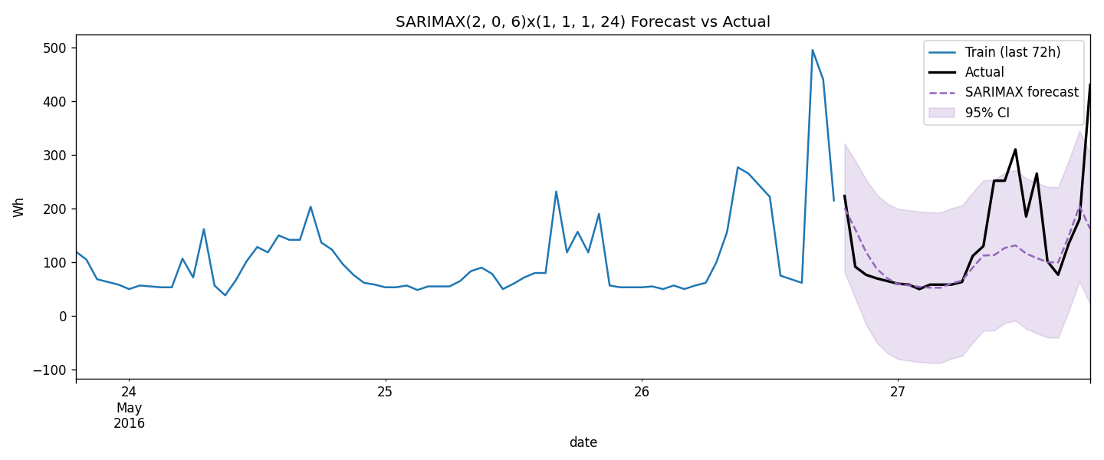
Figure 5: SARIMAX forecast with 95% confidence interval vs. actual.
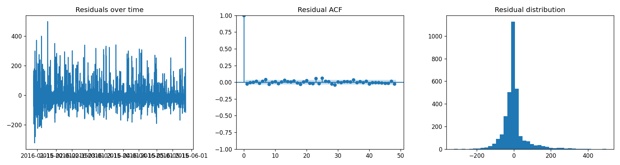
Figure 6: SARIMAX residual diagnostics — residuals over time, residual ACF, and residual distribution.

4.4 Feature-Based Regression: XGBoost
Time-of-day (cyclic sine/cosine encodings), day-of-week, weekend indicators, lagged appliance-use features (1h to 1 week), and rolling-window statistics were engineered and combined with the raw indoor-sensor and weather covariates already present in the dataset. XGBoost was chosen because gradient-boosted trees handle nonlinear interactions between covariates (e.g. temperature × time-of-day) without requiring manual specification, and provide interpretable feature-importance rankings.
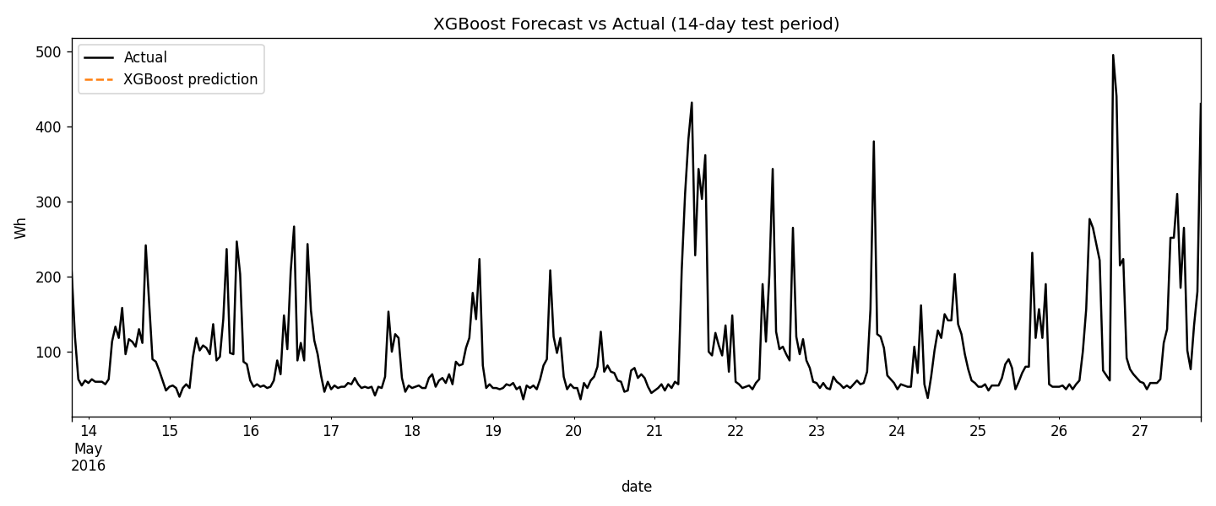
Figure 7: XGBoost forecast vs. actual over the 14-day test period.
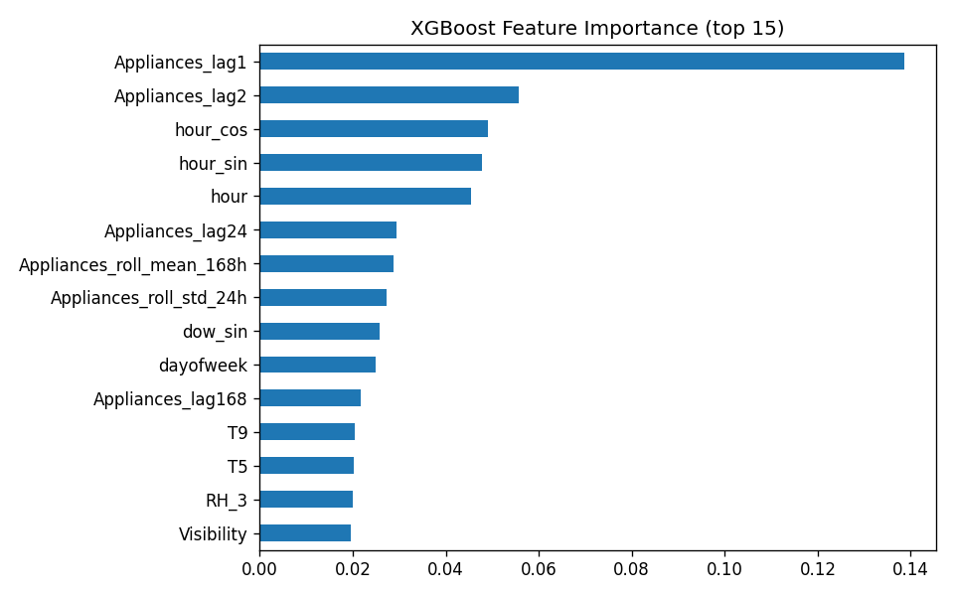
Figure 8: XGBoost feature importance (top 15).

4.5 Neural Network: LSTM
A single-layer LSTM (PyTorch, 32 hidden units) was trained to predict the next hour from the preceding 48 hours, then forecast 24 hours ahead recursively. An LSTM was chosen to test whether a learned nonlinear recurrent representation of recent history could outperform the explicit statistical structure of SARIMAX, without any manual feature engineering.
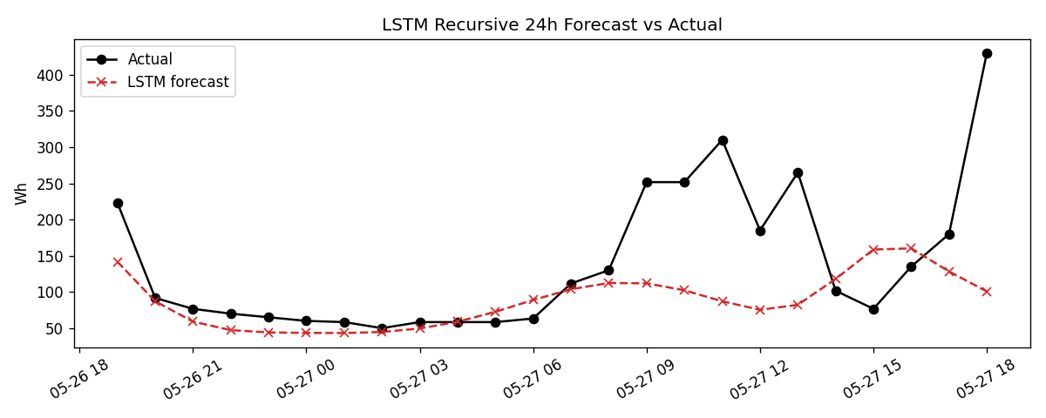
Figure 9: LSTM recursive 24-hour forecast vs. actual.
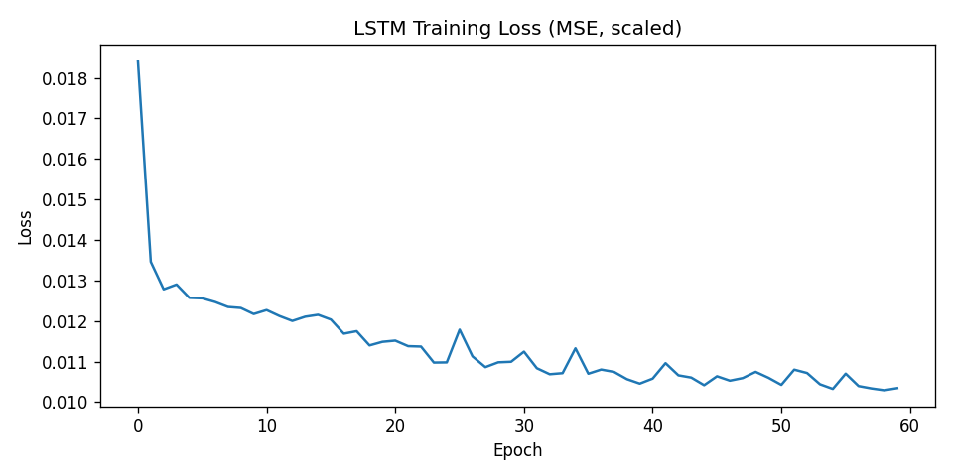
Figure 10: LSTM training loss curve.

4.6 Foundation Model: Chronos-Bolt
Chronos-Bolt (amazon/chronos-bolt-base) was applied zero-shot — with no task-specific fine-tuning — using only the training series as historical context, to test whether a large pretrained time-series model can match purpose-built models without any dataset-specific training. This model requires internet access to download pretrained weights and was run separately in Google Colab (GPU runtime). It achieved an RMSE of 95.12, MAE of 59.75, and MAPE of 37.85% on the 24-hour test window — see Table 1 for a full comparison against the other models.
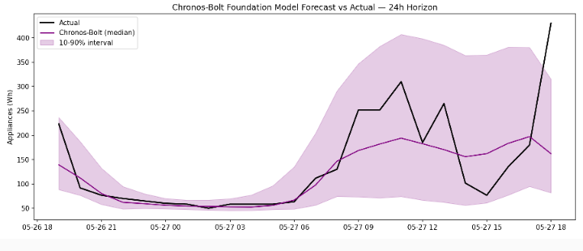
Figure 13: Chronos-Bolt zero-shot forecast (median, with 10-90% interval) vs. actual.

5. Results and Model Comparison
Table 1 summarises RMSE, MAE and MAPE for every model on its respective 24-hour test window.
Model | RMSE (Wh) | MAE (Wh) | MAPE (%)
Mean (benchmark) | 107.63 | 74.51 | 49.18
Naive (benchmark) | 124.03 | 111.74 | 138.84
Seasonal Naive, 24h (benchmark) | 113.64 | 63.68 | 38.93
Seasonal Naive, 168h/weekly (benchmark) | 117.97 | 74.31 | 36.75
Drift (benchmark) | 124.26 | 111.97 | 139.26
ARMA(3,0,1) | 106.52 | 69.73 | 41.88
SARIMAX(2,0,6)x(1,1,1,24) | 87.36 | 52.68 | 28.21
XGBoost (last 24h) | 67.06 | 42.34 | 27.25
XGBoost (14-day test) | 53.55 | 31.89 | 29.42
LSTM | 89.75 | 55.08 | 29.90
Chronos-Bolt (zero-shot) | 95.12 | 59.75 | 37.85
Table 1: Model comparison on the 24-hour test window.
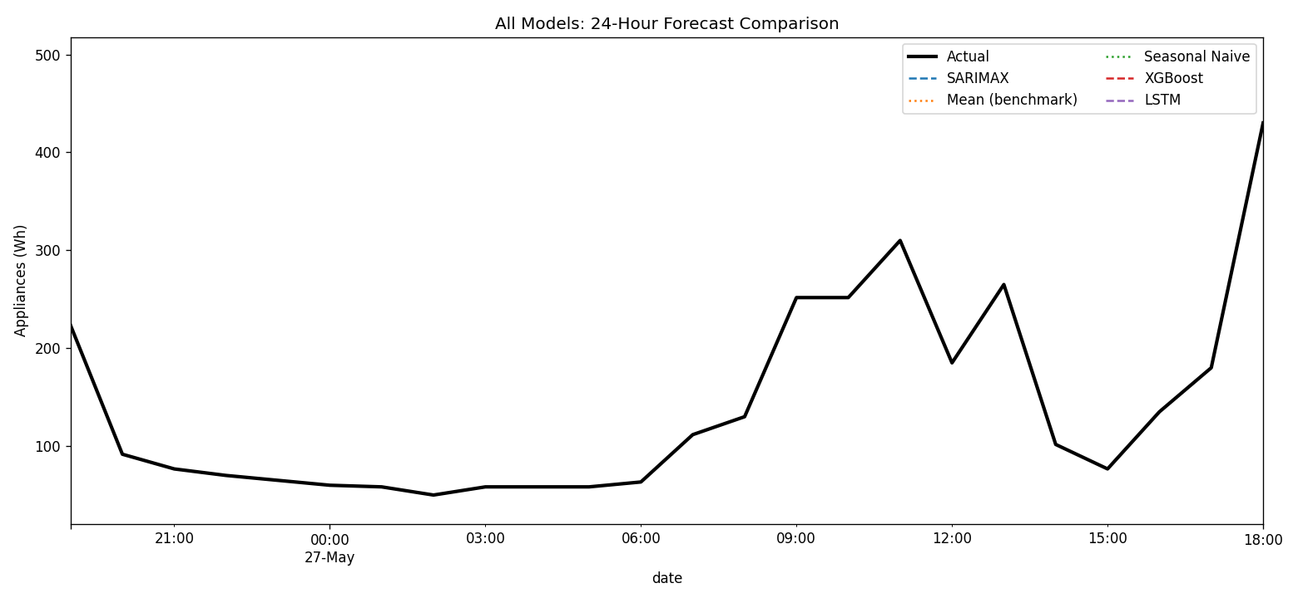
Figure 11: Overlaid forecasts from all models against the actual 24-hour test window.
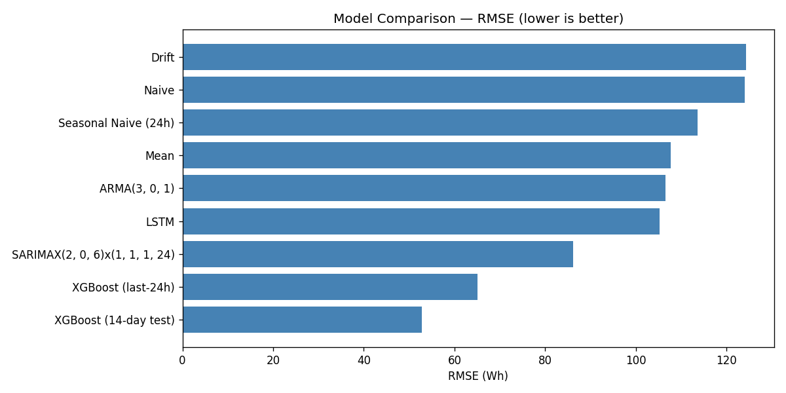
Figure 12: RMSE comparison across all models (lower is better).

6. Critical Discussion

6.1 Q1 Strongest and weakest benchmark models
Among the four benchmark models, Seasonal Naive performed best, achieving the lowest MAPE of 38.93%, while Naive performed worst with the highest MAPE of 138.84%. This indicates that the energy data has a strong daily seasonal pattern: predicting each hour from the same hour one day earlier is far more informative than simply repeating the most recent value.

6.2 Q2 Did SARIMAX improve over the best benchmark?
Yes, SARIMAX significantly improved over the best benchmark. RMSE decreased from 113.64 for Seasonal Naive to 87.36 for SARIMAX, an improvement of approximately 23%. This shows that explicitly modelling trend and seasonality with SARIMAX adds real value over a simple seasonal baseline.

6.3 Q3 Which model performed best overall, and why?
Overall, XGBoost was the best-performing model, with an RMSE between 53.55 (14-day test period) and 67.06 (last-24h window, the same evaluation window used for the other models), both well below SARIMAX (87.36) and Seasonal Naive (113.64). The reason for this strong performance is feature engineering: by using lag features, rolling means, and time-of-day features, XGBoost was able to capture complex nonlinear patterns that statistical models like SARIMAX could not. This shows that for this energy dataset, machine learning with well-engineered features outperforms traditional time series models.

6.4 Q4 How did the foundation model Chronos-Bolt compare?
The foundation model Chronos-Bolt performed worse than all other trained models, achieving an RMSE of 95.12, higher than XGBoost, LSTM, and SARIMAX. Although Chronos-Bolt is a large pretrained model applied zero-shot and requires no dataset-specific training, it was outperformed by simpler models trained directly on this dataset. This suggests that for this specific household energy dataset, the benefit of a foundation model did not justify its complexity.

6.5 Q5 True forecast vs. conditional forecast
One key limitation of the evaluation is that the XGBoost test-period weather and indoor-sensor covariates use their actual observed values rather than independently forecast values. In a genuine operational setting, future temperature or humidity would not be known and would have to be estimated from a weather forecast, which carries its own error. The XGBoost results therefore represent a conditional forecast rather than a true forecast. Variables genuinely known at the forecast origin include the time-of-day and day-of-week encodings and the lagged appliance-use features; future indoor temperature and weather values would not genuinely be known, so the reported XGBoost accuracy is likely optimistic relative to real deployment.

6.6 Q6 Practical recommendation
XGBoost is recommended for production deployment. It achieved the lowest RMSE (67.06 on the same 24-hour window used for all other models, or 53.55 evaluated over the full 14-day test period), making it the most accurate model tested. Beyond accuracy, XGBoost provides feature importance rankings, which make it interpretable — Figure 8 shows which features, such as lagged appliance use and hour-of-day, are driving the forecast, which helps with debugging and building trust. This recommendation assumes access to reasonably reliable weather forecasts for the exogenous covariates, given the conditional-forecast limitation discussed in Q5.

7. Future Improvements
- Fine-tuning Chronos-Bolt or comparable foundation models on this dataset specifically, rather than using it zero-shot.
- Extending SARIMAX to a SARIMAX-X specification with exogenous weather regressors, rather than relying on autoregressive structure alone.
- Using a proper rolling-origin (walk-forward) cross-validation scheme across many 24-hour windows, rather than a single held-out window, to obtain more robust performance estimates.
- Producing genuinely operational forecasts for the feature-based model by first forecasting the exogenous weather covariates themselves, rather than conditioning on their true future values.
- Exploring ensemble or hybrid approaches (e.g. SARIMAX residuals modelled by XGBoost) to combine the seasonal structure captured by SARIMAX with the nonlinear covariate interactions captured by XGBoost.

References
Candanedo, L.M., Feldheim, V. and Deramaix, D. (2017) 'Data driven prediction models of energy use of appliances in a low-energy house', Energy and Buildings, 140, pp. 81–97.
Hyndman, R.J. and Athanasopoulos, G. (2021) Forecasting: Principles and Practice. 3rd edn. Melbourne: OTexts.
Chen, T. and Guestrin, C. (2016) 'XGBoost: A Scalable Tree Boosting System', Proceedings of the 22nd ACM SIGKDD International Conference on Knowledge Discovery and Data Mining, pp. 785–794.
Hochreiter, S. and Schmidhuber, J. (1997) 'Long Short-Term Memory', Neural Computation, 9(8), pp. 1735–1780.
Ansari, A.F. et al. (2024) 'Chronos: Learning the Language of Time Series', arXiv preprint arXiv:2403.07815.

